Official docs: Microsoft Power Platform Center of Excellence Kit - Power Platform | Microsoft Learn
Updated: 12/15/2023
Turn on Power BI Map visuals
In browser logged in as COE service account
- Download the Creator Kit
- Download the COE Core Components
- Create the environment
- Enable Power Apps code components for Canvas apps feature
- Import the Creator Kit
- Import the Core Components (this can take 15 minutes)
In browser logged in as Admin
- Create the app with ActivityFeed.Read (Office 365 Management API) and ServiceMessage.Read.All (MS Graph) and AuditLogsQuery.Read.All (MS Graph) application permissions
- Grant consent for your organization
- Create a client secret
- Copy that info & save it somewhere
- Create 3 M365 Groups
  - Power Admins
  - Power Makers
  - Power Users
In browser logged in as COE service account
- Disable M365 Group welcome email
- Open a different browser tab, change the DelayInventory environment variable to No
- Run the COE Setup and Upgrade Wizard Power App
- Click Next to confirm the pre-reqs
- Set the persona groups, click Next
- Click Next for the default environment variables
- Select the Cloud Flows setup option, click Next
- The wizard will start the 3 pre-req flows (can take 15-30 minutes)
- Back to the Setup Wizard app, click Next to enable the inventory flows
- Click Next to Run the inventory flows (this will take a couple minutes)
- Share the other COE Apps with the corresponding persona group, click Next
- Click Next to finish with Wizard
- Launch the COE Admin Command Center app, select Environment variables
- Set the admin_AuditLogsClientID and admin_AuditLogsClientSecret values
- Turn on the Admin | Audit Logs | Office 365 Management API Subscription flow and run it. Use “start” as the Operation value. Check the history to make sure it is successful
- Turn on the Admin | Audit Logs | Sync Audit Logs (V2) flow to make sure it ran successfully
- Open a different browser tab, change the DelayInventory environment variable to Yes
- Configure and publish the Power BI Dashboard
- Schedule the data refresh
- Open Power BI, go to the COE workspace, click "..." > Settings:
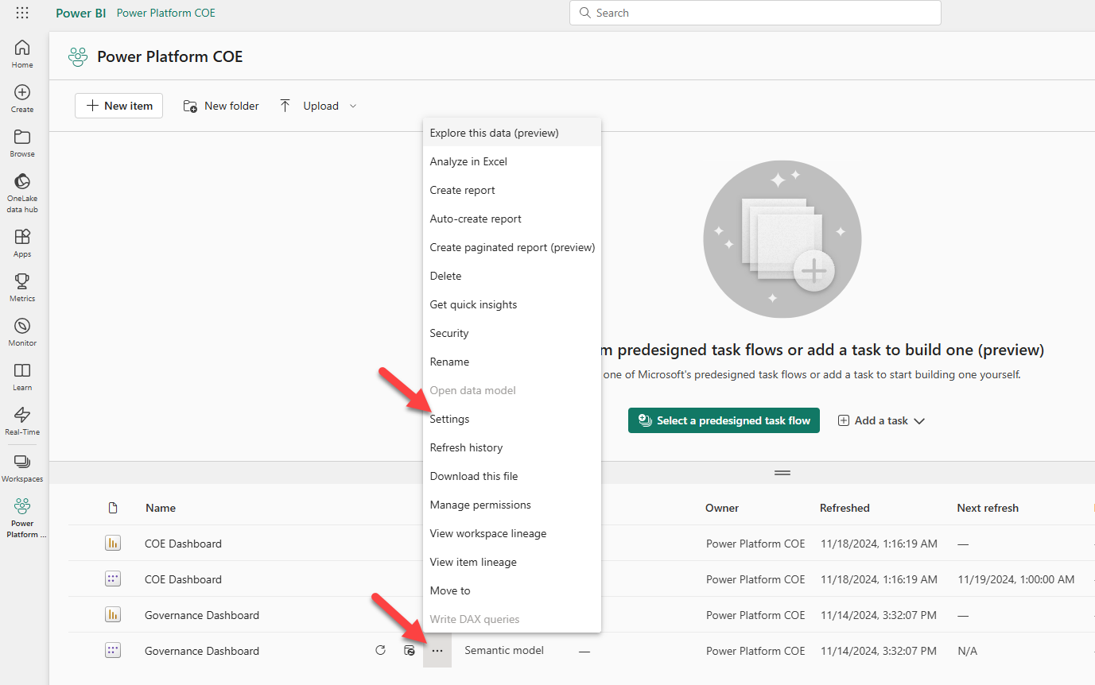
- Go to Refresh > set the frequency, click Apply:
